**Write a script which will capture all the running services and append it to file everday..**

**Below image shown the running services…**

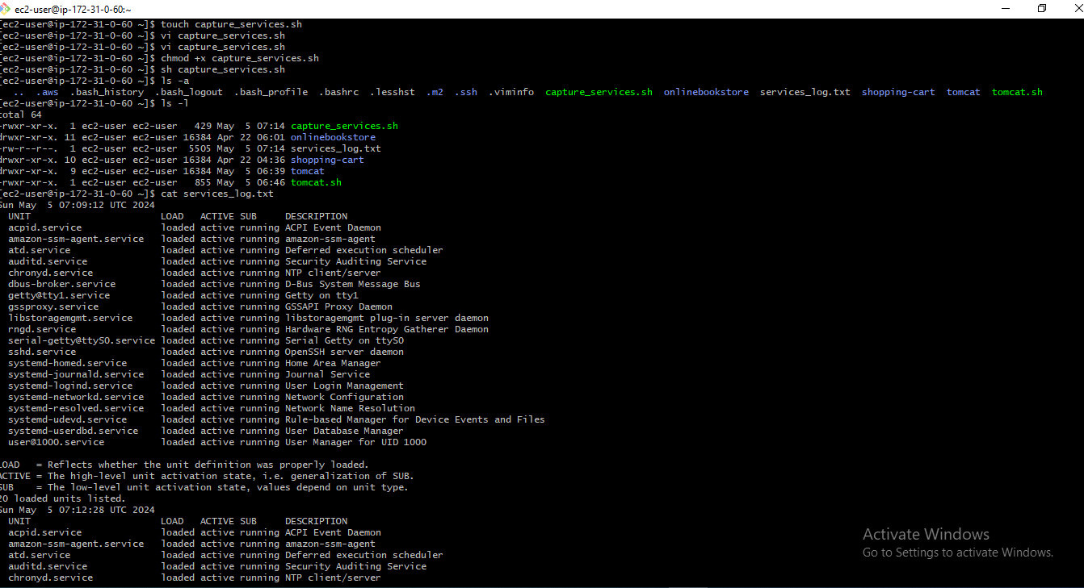

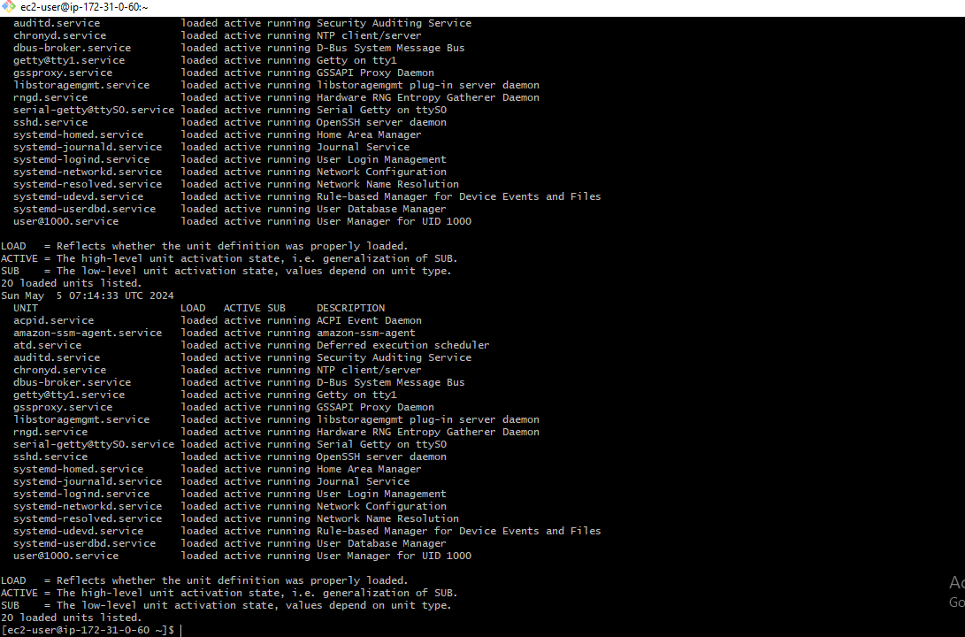

**Here below image shown the service_log.txt…**

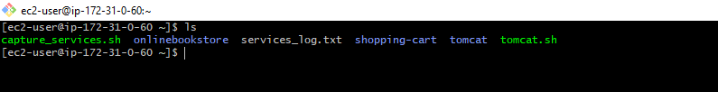

**Script for capturing running services….**

